**CS 3260**

**Spring 2014**

**C# .NET Software Development**

**Lab 03**

**Version 1.0**



**Objectives:**

Write a C# GUI application that is the beginning of a much larger “Object-Oriented Employee Database Program.” Your company **World-Wide Wombats** has four employee classifications; 1) ***Salary***  employees; 2) ***Hourly***  employees (sealed); 3) **Sales** employees (sealed); 4) **Contract** employees (sealed) 5) An **abstract** **Employee** class used as the base class for all employee types. The employees have the following beginning members as shown in the UML

class diagram shown in Fig. 1 below:

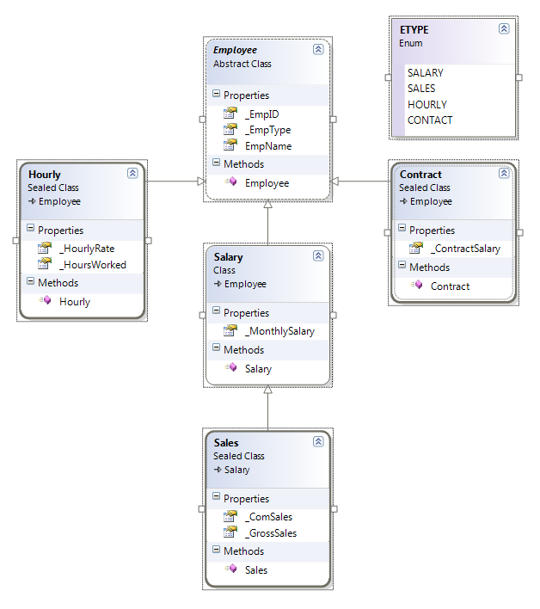

Figure 1 UML Diagram for Employee classes

Note, in Fig. 1, that the classes ***DO NOT*** include all the member fields, properties and methods that will be needed.

For this lab you are to create a Graphical User Interface (GUI), design the all of the employee classes, any other objects you may need and provide your UML diagrams so that they match those of Fig. 1 above. In your GUI Applications, write the C# code that will implement each employee type as an object in memory. Design the GUI interface so that a user can create an employee and enter the required employee data into the correct employee object. It is required that you had a ***“Test Data”*** Button at this point you only need a minimum of data to test your code. Remember: you will, in up-coming labs need GUI, Data, Business Rules and File IO classes.

|  |  |
| --- | --- |
| **Description** | **Points possible** |
| Assignment meets Grading Guidelines:  o Source code files contain a declaration that you did not copy any code, except that provided.  o Assignment has been properly submitted to Canvas  o Code meets Style Guidelines.  o Code contains the required Project and method Prolog’s. |  |
| o This lab meets all the lab specifications. |  |
| o Lab is elegant and efficient and works error free. |  |
| Total | 10 |

Submit your UML diagram and zip your ENTIRE Project folder. If I were submitting this lab, I would name it Lab_03_DAF_V1.0.zip. Submit your lab to Canvas.